**Assignment 2 - The command-line interface**

By – Prabhjot Singh Sains_101495218

**Filename globbing**

1. Use the ls command to see all the files you just created.

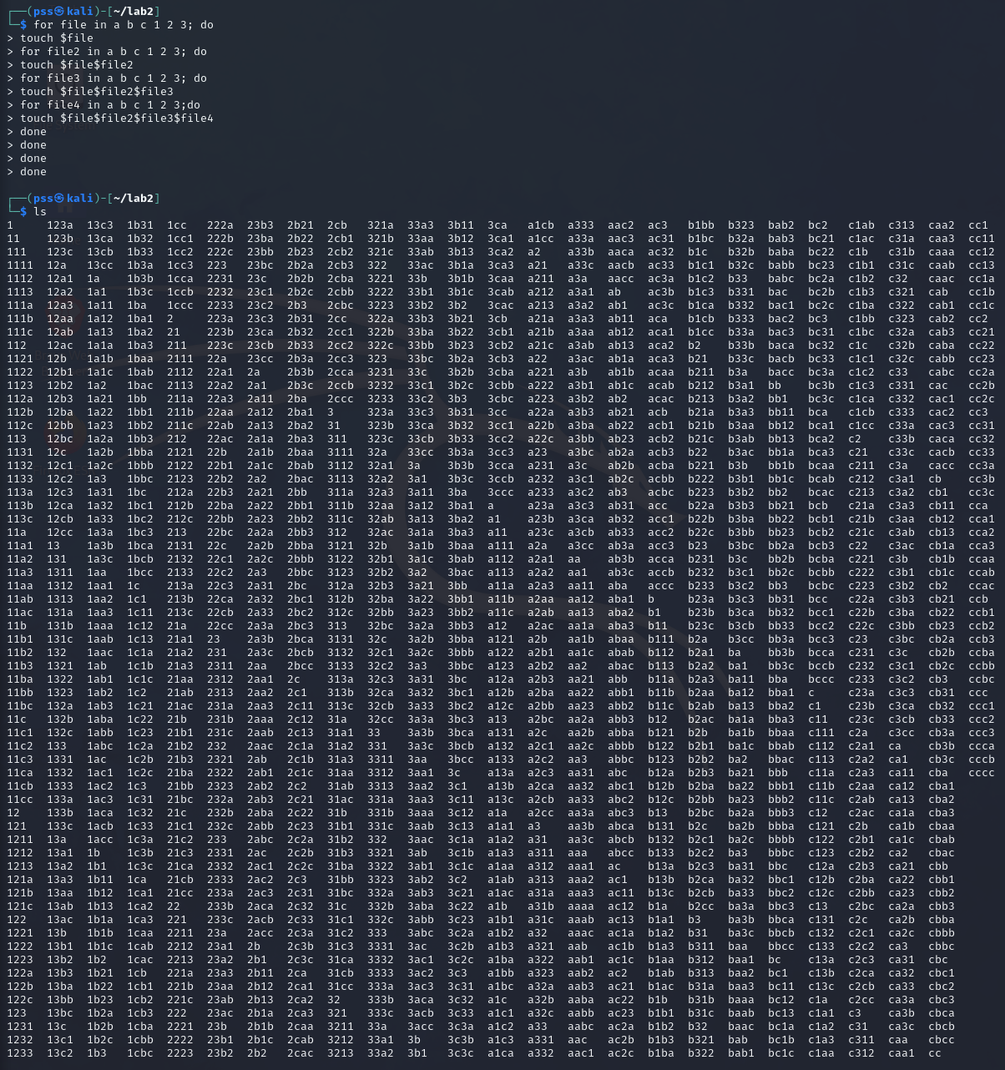

Screenshot 1

1. Create a ls command to display only the files with just a single character filename.

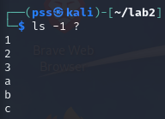

Screenshot 2

1. Create a ls command to only display filenames that start with the letter “a” and are up to 3 characters long (any letters and numbers).

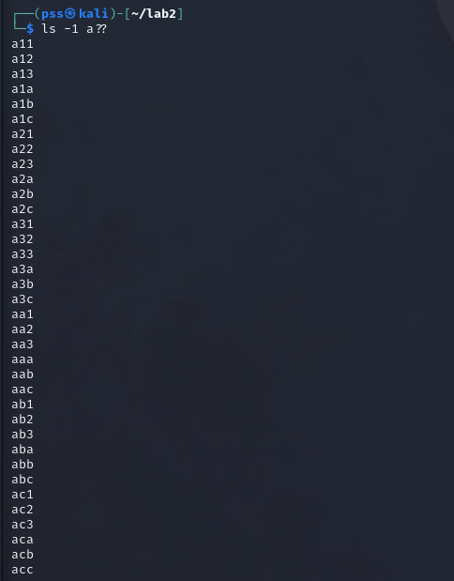

Screenshot 3

1. Create a ls command to only display filenames that have only 2 letters in them (not numbers).

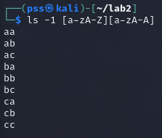

Screenshot 4

1. Create a ls command to only display filenames that are 3-digit numbers (no letters).

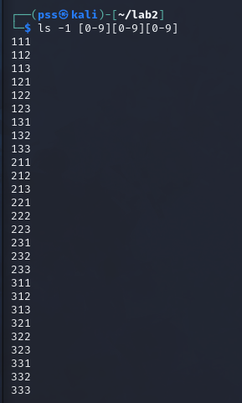

Screenshot 5

**File and folder management**

1. Create a directory under your lab2 directory called “dir_abc”.



Screenshot 6

1. Move all the files starting with letters a, b, or c into the “dir_abc” folder using mv command.

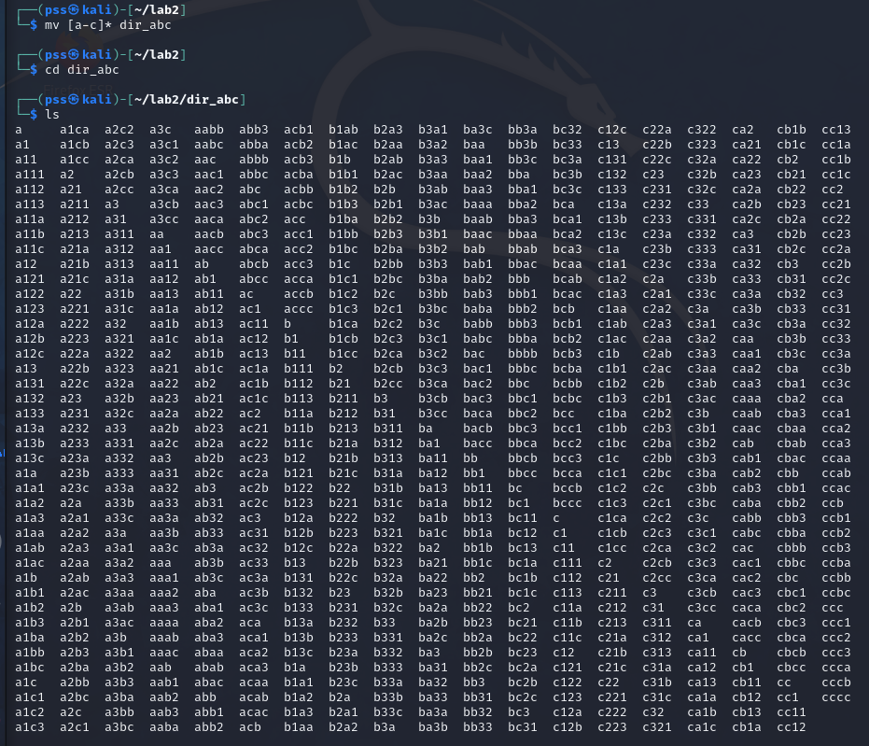

Screenshot 7

1. Copy all the files starting with any number to a new folder called “numbers”.

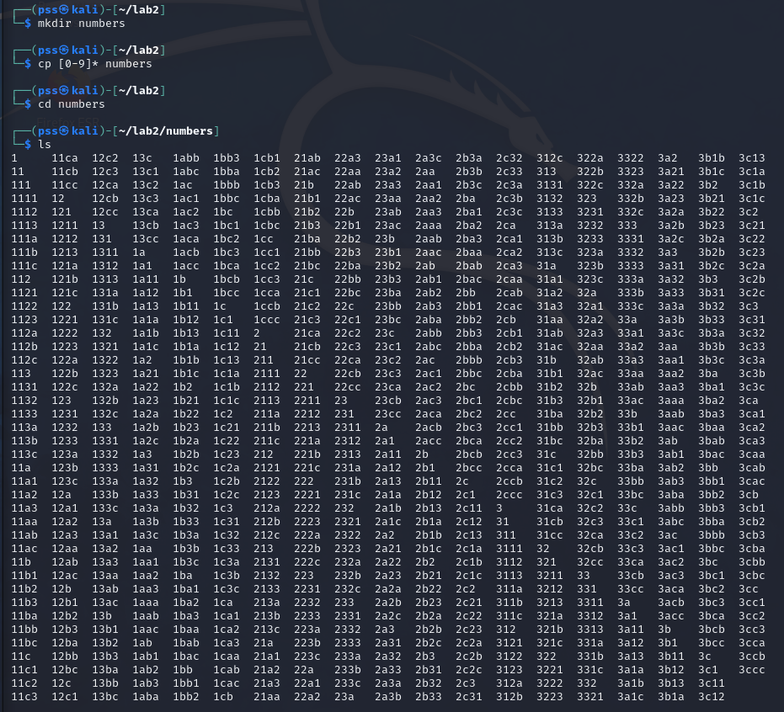

Screenshot 8

1. Remove all the files under the lab2 folder that start with “12” using rm command.

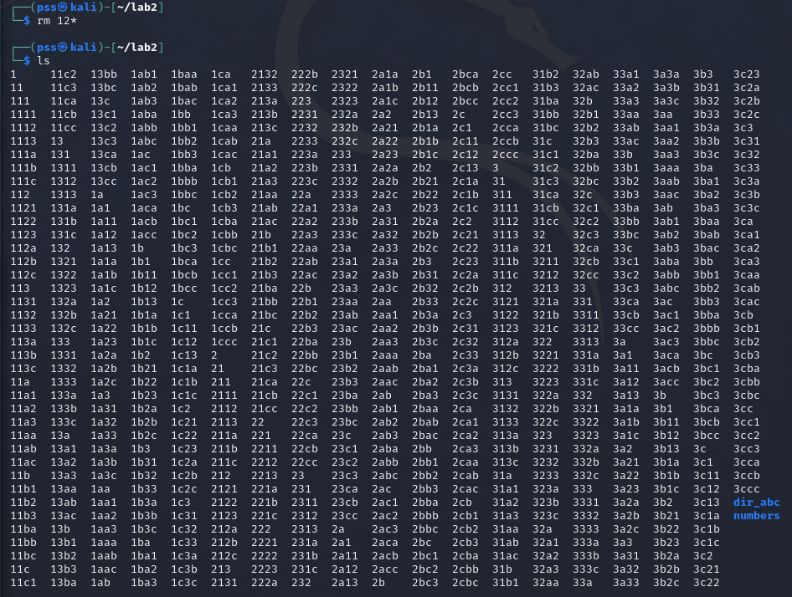

Screenshot 9

1. Remove the “numbers” directory and all its content.

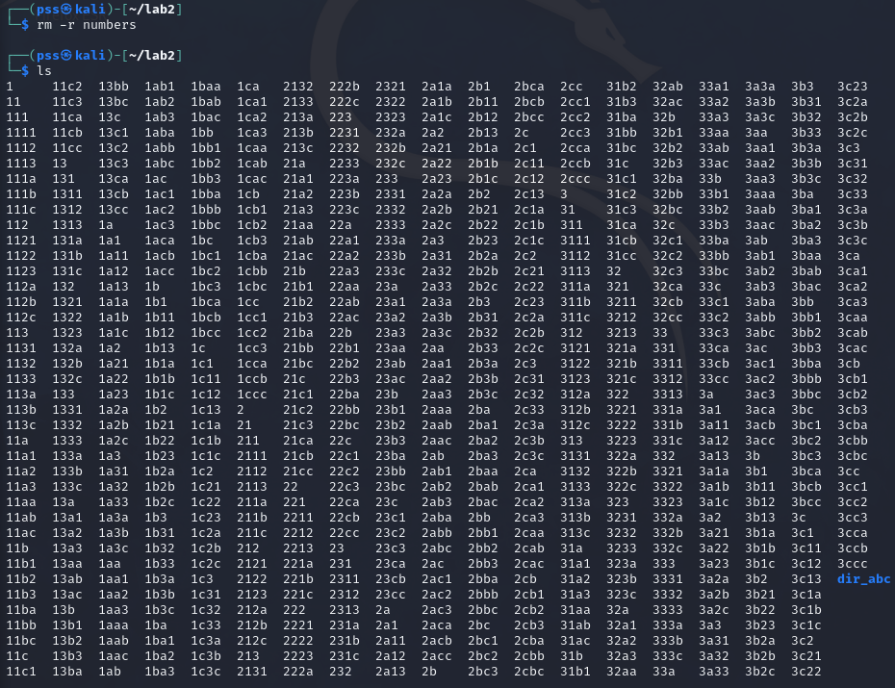

Screenshot 10

**Escaping special characters**

1. Create an echo command to show the following output exactly as it is shown: "Hi. How are you?", he said.

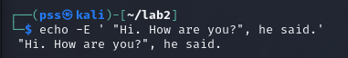

Screenshot 11